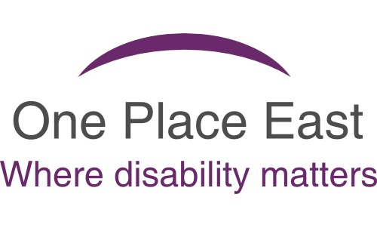

Hate Crime Survey

We would like you to fill in this short survey.
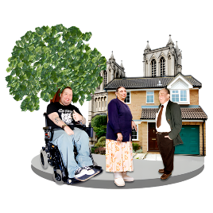
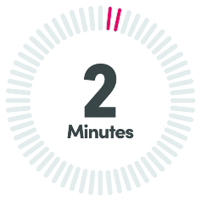
It will help us understand people’s experiences of hate incidents and hate crime in our community.

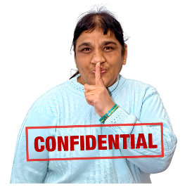
The survey only takes a few minutes.
Your answers are private (anonymous).

Your answers will help us plan future hate crime awareness activities.

If you would like help to fill in this survey, you can contact the One Place East team.

Thank you for your time.


What is a hate incident?

A hate incident is when someone is unkind, rude or unfair to you because of:

- Disability.

- Race or skin colour.
- Religion.

- Being gay, lesbian or bisexual (sexual orientation).

- Being transgender (for example, changing from male to female).


Anyone can experience a hate incident.
For example:

- Someone is unkind because they think you are gay, even if you are not.
- Someone is rude to you because you have a disabled child.

But it doesn’t include violence, threats, or damage.


What is a hate crime?

A hate crime is when someone breaks the law because of hate or prejudice.



This can be about disability, race, religion, being transgender or being gay or lesbian.

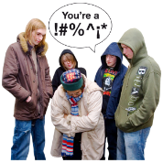

Examples of a hate crime include:
- Shouting abuse.

- Physical attack.
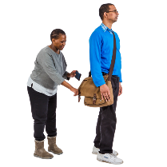
- Damaging your things.
- Stealing from you.

Hate crimes are serious and can lead to arrest and prison time.


In short
- Hate crimes break the law.
- Hate incidents do not.
- Both are motivated by bias toward a protected group.


Survey Questions

Q1. Have you ever experienced a hate incident?

(Select one)
Yes


No

Not Sure


Do you want to tell us about it?


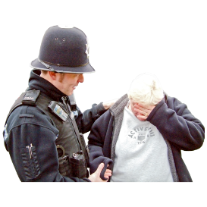
Q2. Have you ever been a victim of a hate crime?
(Select one)

Yes


No

Not Sure


Do you want to tell us about it?


Q3. If you have experienced a hate incident or hate crime, did you report it or get any help?
(Select one)
Yes

No

If you feel comfortable, please give us more details.

Q4. If you answered ‘Yes’ to question 3, please let us know where you reported it or got help.


(Select one or more)

- Police


- Stop Hate UK

- True Vision


- An advocate

- A family member


- Support worker / key worker / carer

- A friend

- Other
If you have ticked ‘Other’ please give us more details.

Q5. Have you ever received support from One Place East about a hate incident or hate crime?

This may have been through a

- Workshop


- Training

- One-to-one advocacy

- Help with forms


- Signposting

- Other

- None

Q6. What kind of support would you like if you were affected by hate crime in the future?

If you feel upset by any of the questions, or want to speak to One Place East, please tell us how to contact you.

Name:

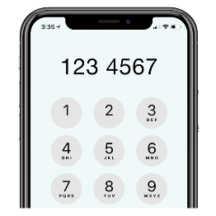
___________________________________________
Contact details:

____________________________________________

