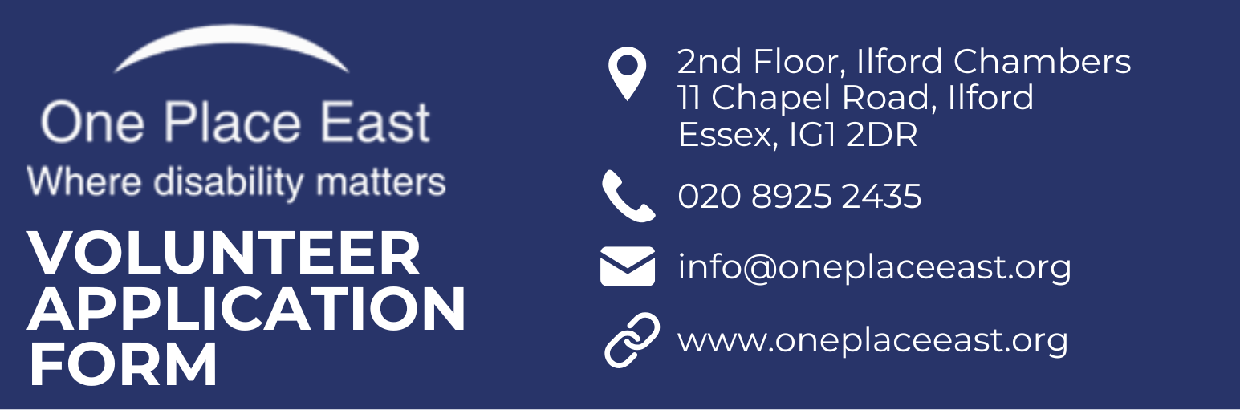
Please tick the project you would like to volunteer for:

Mental Health Befriending Community Befriending (1:1 or remote)

SECTION A – About you:

Title: Surname:

First name: D.O.B:

Address:

City: Postcode:

Email:

Home No: Mobile:

Languages Do you

Yes ☐ No ☐
spoken: drive?

Office use only:

Application returned: Interview date: References sent:

References received: DBS submitted: DBS received:

SECTION B: Previous experience (including any voluntary work):
Please describe any previous experience you have – either in employment, or as a volunteer

SECTION C – Supporting Statement:
Please explain why you would like to volunteer with One Place East and the skills and qualities you will bring to the role

Section D – Availability:
Please indicate when you would be available: | Monday am/pm ☐ | Tuesday am/pm ☐
Please indicate when you would be available: | Wednesday am/pm ☐ | Thursday am/pm ☐
Please indicate when you would be available: | Friday am/pm ☐ | Saturday am/pm ☐
How much time can you offer per week?
Any other comments:
Section E – References:
Please provide the names of two referees who can provide you with a character reference. This has to be someone who has known you for at least two years and cannot be a family member.

Referee 1:
Full Name:
Position:
Address:
Relationship to you:
Telephone Number:
Email address:

Referee 2:
Full Name:
Position:
Address:
Relationship to you:
Telephone Number:
Email address:

Section F – Declaration:

Rehabilitation of Offenders Act 1974: Because of the nature of the role for which you are applying, this post is exempt from the provision of Section 4(2) of the Rehabilitation of Offenders Act 1974. Applicants are therefore not entitled to withhold information about convictions which for other purposes are “spent” under the provisions of the act. In the event of your successful application to be placed as a volunteer within One Place East, any failure to disclose such convictions could result in immediate dismissal. Any information given will be completely confidential.
A criminal conviction will not necessarily affect your right to do voluntary work.Note: All staff and volunteers will be required to undergo an enhanced Disclosure and Barring Service check. One Place East will cover the cost of the application.
Self-disclosure of criminal record information:
Do you have any convictions? | Yes ☐ | No ☐
If yes, please give details:

Your right to work in the UK:
Do you have the right to undertake voluntary work in the UK? | Yes ☐ | No ☐

Access requirements:
Are there any special needs you would like us to be aware of? | Yes ☐ | No ☐
If yes, please give details:

Privacy Statement:
We process personal data relating to those who apply for volunteering roles with us. We do this to assist us in the selection of volunteers, and to assist in the running of the organisation. The personal data may include identifiers such as name, date of birth, personal characteristics such as gender, qualifications and previous employment history.

We will not share any identifiable information about you with third parties without your consent unless the law allows or requires us to do so. The personal data provided during an application process will be retained for a period of at least six months or, if required by law, for as long as is required.

This privacy notice does not form part of a volunteering contract between us. If you become a volunteer with One Place East, we will provide further information about our handling of your personal information in a volunteering context separately.

If you would like to find out more about our data retention policy and how we use your personal data; you want to see a copy of the information about you that we hold or have any questions or issues regarding data protection, please email us with the Subject “Data Protection Request”.

Declaration:
I confirm that all the details I have provided in this application form are correct and that I have not deliberately withheld any relevant information.

I understand that deliberately providing false information or failing to disclose relevant information may lead to my application being rejected.

Signature: | Date:

Please ensure all sections of this form are completed and then return this form by post to: One Place East, Ilford Chambers, 11 Chapel Road, Ilford, IG1 2DR

Or via email to: info@oneplaceeast.org

EQUAL OPPORTUNITIES MONITORING

To help us monitor the effectiveness of our policy, please complete this form. The information will be used solely for monitoring purposes and treated as strictly confidential.

ETHNIC ORIGIN:

Please tick the category which you feel best describes your ethnic origin:

WHITE: |  | BLACK OR BLACK BRITISH:
British |  | Caribbean
Irish |  | African
Any Other White Background |  | Any Other Black Background
MIXED: |  | ASIAN OR ASIAN BRITISH:
White and Black Caribbean |  | Indian
White and Black African |  | Pakistani
White and Asian |  | Bangladeshi
Any other Mixed Background |  | Any Other Asian Background
OTHER ETHNIC GROUPS:

Chinese |  | Prefer not to say
Any Other Ethnic Groups |  | ____________________________

DISABILITY:

The disability discrimination act defines disability as ‘a physical or mental impairment which has a substantial and long-term adverse effect on your ability to carry out normal day to day activities’.

Do you consider yourself to have a disability? | Yes ☐ | No ☐ | Prefer not to say ☐

AGE:

Please choose one of the options below:
Age Groups | 16 – 17 ☐ | 18 – 24 ☐ | 25 – 44 ☐ | Prefer not to say ☐
Age Groups | 45 – 54 ☐ | 55 – 64 ☐ | 65 + ☐ | Prefer not to say ☐

RELIGION:

I would describe my religion as the following (please indicate one):
None  ☐ | Christian  ☐ | Buddhist  ☐ | Hindu  ☐ | Muslim  ☐
Sikh  ☐ | Jewish  ☐ | Other (please specify): |  | Prefer not to say  ☐

GENDER AND SEXUAL ORIENTATION:

Answering this question will help us to monitor our recruitment practices and recognise the diversity needs of our volunteers. However, we understand that how people define their sexual and/or gender orientation is a personal choice and understand if you prefer not to respond to this question.
I would describe myself as the following (please indicate one):
Female ☐ | Male ☐ | Intersex ☐
Non-binary ☐ | Transgender ☐ | Prefer not to say ☐
If you prefer to use your own term, please specify here _______________________

I would describe myself as the following (please indicate one):
Heterosexual ☐ | Homosexual ☐ | Lesbian ☐
Bisexual ☐ | Other ☐ | Prefer not to say ☐
If you prefer to use your own term, please specify here ________________________

EMPLOYMENT:

Employment Status:
Employed Full Time ☐ | Employed Part Time ☐ | Retired ☐
Self Employed ☐ | Unemployed ☐ | Prefer not to say ☐

Please return this form with your application form.

