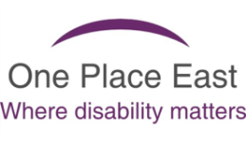
One Place Creative and SPACE

Registration Form

Participant Details:

Full Name:

Address: | Postcode:
Contact Number:

Email:

D.O.B: |  | Gender: | ☐ Male  ☐ Female
Employment Status:
☐ Self-employed ☐ Employed ☐ Unemployed/state benefits
☐ Retired p ☐ Full time student ☐ Other

Which workshop are you applying for?

Building a mobile workshop
What is the dates of the Workshop? | 21st and 22nd Sept.

Office Use Only:
Compulsory tasks completed:  ☐ Data consent form  ☐ Equal opportunities form | Client interested in workshops:  ☐ Money management  ☐ Digital access  ☐ Welfare benefit entitlements/HMRC

Support channels used: | Category:
☐ Face to face  ☐ Telephone  ☐ Email  ☐ Group meeting/workshops  ☐ Home visit | ☐ Over 55/ Pensioner  ☐ Migrants/refugee  ☐ Disabled (physical/mental health)  ☐ Student  ☐ Digitally excluded (no access)  ☐ Digital assistance needed  ☐ Single parent  ☐ Other vulnerable group
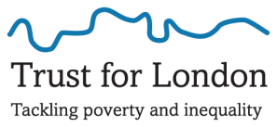

Data Consent Form

Firstly, we need to reassure you that One Place East is committed to keeping your data secure. We will only collect data that is necessary for us to be able to continue to provide you with a service, to contact you and to comply with the monitoring requirements of our funders. Any information that is given to our funders is in an anonymized form.

Under the new regulations you have certain rights. These include the right to view the data we hold on you and to make any corrections that may be necessary. You also have the right to object to us holding your personal data, however, please be aware that this option would mean that you will need to return the card to us for destruction as we would have to delete your details from our systems.

We will hold your information on our systems until you advise us that you no longer wish to receive a service. After this, we will only use your data to comply with any subsequent legal requirements and then we will either delete or anonymise your data.

If the person directly receiving a service is unable to sign then the form should be signed by someone on their behalf.

☐ I give consent for One Place East to hold my data in line with the new General Data Protection Regulations. *

☐ I do not give consent for One Place East to hold my data in line with the new General Data Protection Regulations *

* Please tick as appropriate.

Name of person receiving a service: _______________________________

Signed ………………………………………………………

Date …………………………………………………………

If signed on behalf of the person receiving a service, please complete below:

Name: ………………………………………………………

Signed ………………………………………………………

Relationship:……………………………………………….

Date …………………………………………………………

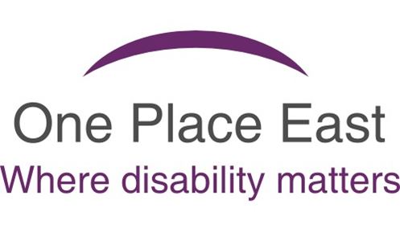

EQUAL OPPORTUNITIES MONITORING
In order to help us monitor the effectiveness of our policy, please complete this form. The information will be used solely for monitoring purposes and treated as strictly confidential.

ETHNIC ORIGIN:

Please tick the category which you feel best describes your ethnic origin:

WHITE: |  | BLACK OR BLACK BRITISH:
British |  | Caribbean
Irish |  | African
Any Other White Background |  | Any Other Black Background
MIXED: |  | ASIAN OR ASIAN BRITISH:
White and Black Caribbean |  | Indian
White and Black African |  | Pakistani
White and Asian |  | Bangladeshi
Any other Mixed Background |  | Any Other Asian Background
OTHER ETHNIC GROUPS:

Chinese |  | Prefer not to say
Any Other Ethnic Groups

DISABILITY:

The disability discrimination act defines disability as ‘a physical or mental impairment which has a substantial and long term adverse effect on your ability to carry out normal day to day activities’.

Do you consider yourself  to have a disability? | Yes ☐ | No ☐ | Prefer not to say ☐

AGE:

Please choose one of the options below:
Age Groups | 16 – 17 ☐ | 18 – 24 ☐ | 25 – 44 ☐ | Prefer not to say ☐
 | 45 – 54 ☐ | 55 – 64 ☐ | 65 + ☐

RELIGION:

I would describe my religion as the following (please indicate one):
None  ☐ | Christian  ☐ | Buddhist  ☐ | Hindu  ☐ | Muslim  ☐
Sikh  ☐ | Jewish  ☐ | Other (please specify): |  | Prefer not to say  ☐

GENDER AND SEXUAL ORIENTATION:

Answering this question will help us to monitor our recruitment practices and recognise the diversity needs of our volunteers. However, we understand that how people define their sexual and/or gender orientation is a personal choice and understand if you prefer not to respond to this question.
I would describe myself as the following (please indicate one):
Female ☐ | Male ☐ | Transgender ☐

I would describe myself as the following (please indicate one):
Heterosexual ☐ | Homosexual ☐ | Lesbian ☐
Bisexual ☐ | Other ☐ | Prefer not to say ☐

EMPLOYMENT:

Employment Status:
Employed Full Time ☐ | Employed Part Time ☐ | Retired ☐
Self Employed ☐ | Unemployed ☐ | Prefer not to say ☐

Please save this and email it to saifur.valli@oneplaceeast.org

THANK YOU

